**Cognizant Technology Solutions**

**Diagnostic Medicare Center Management System**

**Business Requirements Document**

**V1.0**

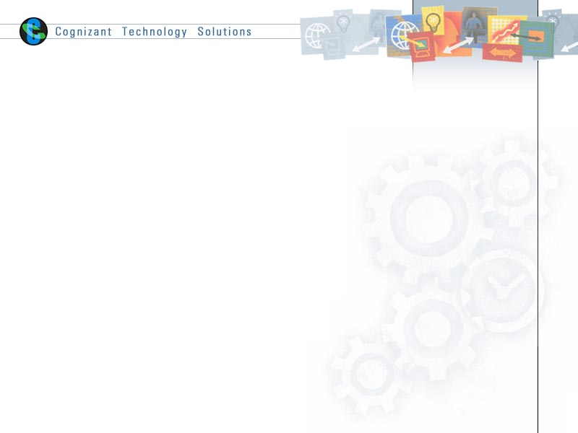

|  |  |  |  |
| --- | --- | --- | --- |
|  | Prepared By / Last Updated By | Reviewed by | Approved By |
| Name | Anisha S.  Bertram Russell  Deepali Jain  Nitin Paul  Sahil Sood |  |  |
| Role |  |  |  |
| Signature |  |  |  |
| Date |  |  |  |

# Table of Contents

1.0 Introduction 3

1.1 Purpose of this document 3

1.2 Project Overview 3

1.3 Scope 3

1.3.1 In scope 3

1.3.2 Out Scope 3

1.4 Intended Audience 4

1.5 Constraints, Assumptions and Dependencies 4

1.6 Definition & Acronyms 4

2.0 Organization Architecture 5

2.1 TRICARE 5

2.2 Cognizant Technology Solutions 5

3.0 Business Process Analysis 6

3.1 Current Scenario 6

3.1.1 ‘As-is’ Process Flow 6

3.2 Proposed Solution 6

3.2.1 ‘To-be’ Processes 6

4.0 Process Definitions 7

4.1 Business Rules 10

5.0 High Level Business Requirements 13

6.0 Detailed Business Requirements 14

7.0 Objective and Expectation Traceability 19

7.1 Business Objective Traceability Matrix 19

8.0 References 19

9.0 Change Log 20

# Introduction

## Purpose of this document

This document is aimed at

* Providing the necessary inputs to the detailed requirements gathering phase and further on for the SDLC processes.
* This document also serves to establish the traceability between the Business Objectives and the requirements identified in the proposed solution and how they satisfy the stated objectives.
* Provide expectation traceability in terms of the requirements and the user expectation
* Serves as a formal template for documenting the Business Requirements which also includes statutory and regulatory requirements.

## Project Overview

Cognizant is the Medicare Health Center where customers get registered manually. A lot of paper work and manual effort is spent in registering and giving appointments to the customers. It is too slow and cannot provide updated lists of patients within a reasonable timeframe. The main intent of this project is to simplify this process and configure the workflow in such a way that the customer details are effectively tracked.

## Scope

### In scope

The scope of the system is explained through its modules as follows

* **Create account** – will be used by the customer to create an account when they want to be a member of the Diagnostic center.
* **View Medicare Service**- will be used by the customer to view the Medicare service that is available.
* **Apply Health Checkup**– will be used by the customer to apply for the health check that they are in need.
* **Medical Insurance agent and services** - will be used by customer to talk to a medical insurance agent to get the medical policy details.
* **Medical Reports Online** – will be used by the customer/Doctor wants to view the medical reports

### Out Scope

* Migration of current patient list into the application
* Notification process

## Intended Audience

* All associates going for the initial study at new accounts/projects.
* Associates preparing the white papers/proposals for these accounts/projects.
* Delivery Assurance Group, Process Engineering group

## Constraints, Assumptions and Dependencies

**Assumptions**:

* The DMS customer must possess transaction data along with their default status for all the agents.
* There will be no concurrent users for the application. The user profile will be maintained by the Admin.
* Any changes to the requirements mentioned in the BRD would be taken as a Change Request.

**Risks**:

* If there is any failure in making diagnosis, the system should be able to handle such a financial risk.

**Constraints:**

* Application should have single login feature. Login functionality should be the welcome feature for the application.
* Only administrator and customers can access the application.
* None of the application features can be accessed without login.

**Dependencies**:

* N/A

## Definition & Acronyms

|  |  |
| --- | --- |
| **Acronyms** | **Definitions** |
| RL Document | Regulation/Legislation document. |

# Organization Architecture

## TRICARE

This table provides a view of the client organization as it applies to this application development project.

|  |  |  |  |
| --- | --- | --- | --- |
| Name & Position | Primary Responsibilities  (relative to project) | Module | Primary Responsibilities  (relative to application business process) |
| HR Head, TRICARE | Sponsor | Diagnostic Medicare Center Management System | Laying down HR Policies |
| HR Manager | Employee Management and Compliance Tracking, project Forming the business rules of the proposed project. | Diagnostic Medicare Center Management System | Setting down the rules |
| HR Executive | End users of the system who make entries of personnel details into the system | ADD/EDIT/DELTE/ VIEW users with their Details    Create RL Document and maintain Status Report |  |

## 2.2      COGNIZANT

|  |  |  |  |
| --- | --- | --- | --- |
| Name & Position | Primary Responsibilities  (relative to project) | Module | Primary Responsibilities  (relative to application business process) |
| Delivery Manager | Responsible for timely delivery of project | Diagnostic Medicare Center Management System | Laying down HR Policies |
| Architect | Defining the architecture and design of the system | Diagnostic Medicare Center Management System | Setting down the rules |

# Business Process Analysis

## Current Scenario

### ‘As-is’ Process Flow

As per the current process, the medicare center registers users manually on request. To obtain the list of medicare services, users must raise a request at the reception/help desk, and the respective authorities must manually check and provide the information in printed format. To register for a health checkup, users must register at the reception. The registration details are then manually recorded by the medicare center. To avail information regarding the medical insurance policies and the agent details, users must again raise an inquiry at the reception. The receptionist must check for the details manually and provide the information in printed format. To obtain the medical report, users must raise a request and wait for the doctor to create the report and forward it to the user.

So the new system is required to automate the entire medicare center process.

## Proposed Solution

### ‘To-be’ Processes

* Users can now register online without standing in queue
* Users can easily view the medicare services available based on various criteria
* Users can register for health checkups easily with zero paperwork
* Users can view the various medical insurance services and contact details of insurance agents instantly
* Users can view their medical report instantly

# Process Definitions

### Use Case Diagram

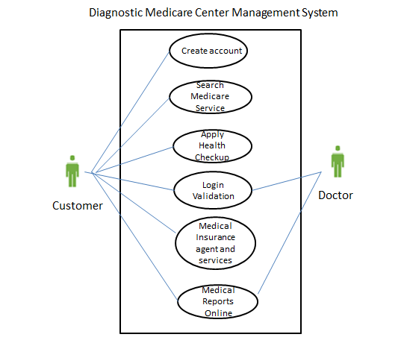

### 

### Data Flow Level 0:

New user registers into system

Administrator

User

Apply for

Health Check-up Add Doctor

Approves Request

Diagnostic Medicare Center Management System

View medical

Reports

View

Medicare service

View medical

Get patient Reports

Details

Doctor

Data Flow Level 1:

Create Account

Admin

Register

Customer

Add Doctor

Doctor

Apply health Check-up

View Medical Service

Medical Insurance Agents & Services

Login

Authentication

Login

Password

Report ID

View medical reports

DOB

Valid User

Databasee

Database

Databasee

### System diagram

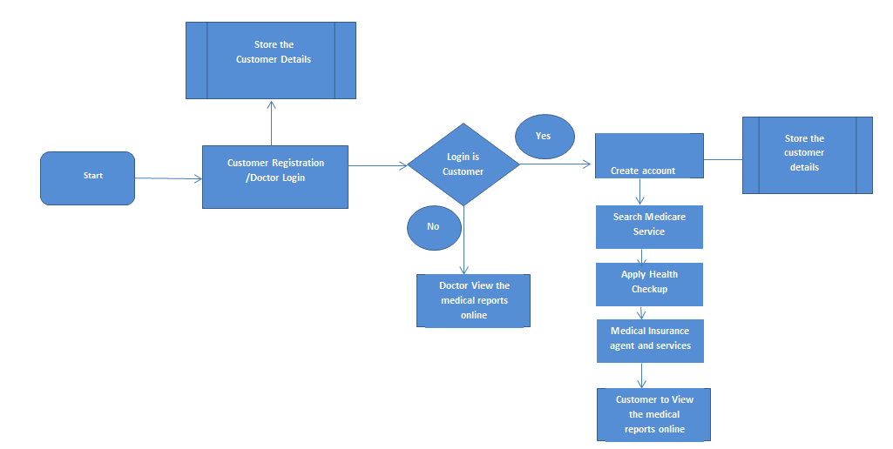

## Business Rules

Business rules should be defined using the following attributes:-

* Business rule could be either a term or a constraint.
* Business rule could be a statement that defines or constraints key aspect of the business
* Business rule should be 'atomic' so that it cannot be broken down or decomposed further into more detailed business rules

| # | Rule Name | Definition |
| --- | --- | --- |
| 1) | Business Validation for Home module | The following elements should be displayed in the home module:   * Customer * About Us * Contact Us |
| 2) | Mandatory Fields in User details | The system should check if the following information are being entered while creating a new user account   * User ID * Password * Date of birth * Email - ID   Appropriate message should be thrown as an alert. |
| 3) | Business Validation in User details | The system should check if the following conditions are met by the data entered during registration:   * User Id should be a number and must be 6 digits long. * Password length should have minimum 8 chars and max 20 chars, at least 1 special chars and at least 1 number.   Appropriate message should be thrown as an alert. |
| 4) | Business Validation in Medicare Search Module | The system should display the following elements:   * Search bar * Service_ Features, Service_Benefits, and Service Parameters should be displayed in results |
| 5) | Business Validation in health checkup application | The system should check if the following information are being entered while applying for health checkup:   * Name should only contain characters * Email ID must contain ‘@’ and ‘.’ characters * Mobile Number must be numeric * City name should only contain characters * PIN code should be numeric * If the customer click ‘I do not agree’ the customer should be navigated to the home screen   Appropriate message should be thrown as an alert. |
| 6) | Mandatory Fields in Medical Insurance Agents Details Search | The system should check if the following information are being entered while searching for medical insurance agents:   * Street Address * City * State * Zip Code   If invalid data is entered, the following error message should be displayed:  Please enter a valid zip code or city/state |
| 7) | Mandatory Fields in Medical Report Request | The system should check if the following information are being entered while searching for medical report:   * Customer Name * Date of Birth * Email ID * Mobile Number * Doctor Name |
| 8) | Business validation in Medical Report Request | The system should check if the following conditions are met by the data entered while searching for medical report:   * Report ID should be of 2 character, the first character should be an alphabet and the second character should be number * Customer Name should be only of characters * Mobile Number should be entered in numerals * Doctor Name should be only of characters |

# 

# High Level Business Requirements

|  |  |  |  |  |
| --- | --- | --- | --- | --- |
| Sno. | Business Requirement ID | Short Description | Description in detail | Interacting Business Processes |
| 1) | BR001 | To create an account | Should allow user to register. | NA |
| 2) | BR002 | To view all the medicare service | There is provision where customer can view all the medicare service. | NA |
| 3) | BR003 | Apply for Health Check Up plan | Should allow customers to request for health check up plan they are in need of. | NA |
| 4) | BR004 | Medical Agent insurance and services | Should allow customers to select medical agent to know about the  medical insurance policy. | NA |
| 5) | BR005 | Medical reports online | There is provision where customers/doctors can view the reports online. | NA |

# 

# Detailed Business Requirements

Additionally, the following elements should be captured for each business requirement in the table provided below;-

* Req. Type = (F Core Functionality, E Exception, UI User Interface, R Reporting)

** Priority of Requirement = (1=Base Functionality, 2=Advanced Functionality, 3=Additional Opportunities)

** Originator = (Name of the business process of the system/ department or function name in the customer organization)

| Req. # | Business Requirement | Req. Type * | Priority ** | Originator *** | BR Traced to Business Requirement/ Use case ID |
| --- | --- | --- | --- | --- | --- |
| BR001 | When the users enter the following link http://localhost/DiagnosticMedicareManagementsystem in the browser, Home page appears which will have a short welcome message; a brief introduction to the purpose of the Diagnostic Medicare center Management System, the user can choose appropriate options. Under home page, we need below interface.  1. Customer  2. About Us  3. Contact Us | F | 1 | Diagnostic Medicare Center Management System | N/A |
| BR002 | 1. User Id – Customer should enter the user id  2. Password – The customer should able to provide the password with( Combination of at least one number, one lowercase, one uppercase letter and at least eight characters)  3. Date of Birth – The customer should able to enter the DOB in DD/MM/YYYY  There should be 2 buttons i.e. Register, reset. | UI | 1 | Diagnostic Medicare Center Management System | N/A |
| BR003 | 1. System should display all the necessary fields.  2. System need to display the Medicare service names, service features, service benefits.  3. All the necessary validation should be done.    4. Identify the MEDICARESERVICE_MASTER table storing the available service names.  5. Identify the MEDICARESERVICE_DETAILS table storing the service details briefly | UI | 1 | Diagnostic Medicare Center Management System | N/A |
| BR004 | 1) View: The customer should be able to view all the Health checkup plan they are in need of.  2) Select: The customer should be able to select the checkup plan once they have searched for it.  3) Apply : The customer should be able to apply for the checkup plan once they have selected for it. | UI | 1 | Diagnostic Medicare Center Management System | N/A |
| BR005 | 1. User id :Customer should be able to enter the User id  2. Password: Customer should be able to enter the password.  3. Select: The customer should be able to select the option to find out the medical insurance agent.  4. Location details: The customer should be able to enter the location details from where they need the medical insurance agent. | UI | 1 | Diagnostic Medicare Center Management System | N/A |

# 

# Objective and Expectation Traceability

## Business Objective Traceability Matrix

|  |  |  |  |  |  |
| --- | --- | --- | --- | --- | --- |
| Business Objective | Business Requirement Number | Priority | Requirement Title | How requirement satisfies objective | Status |
| To create an account for the new customer | 1 | High | Diagnostic Medicare Center Console | Users can register online. | OPEN |
| To view any medicare service | 2 | High | Diagnostic Medicare Center Console | Users can view for required medicare service. | OPEN |
| Apply for any Health Checkup | 3 | High | Diagnostic Medicare Center Console | Users can apply for health checkup | OPEN |
| To find medical insurance agents and services | 4 | High | Diagnostic Medicare Center Console | Users can search for insurance agents and services. | OPEN |
| To view medical reports online | 5 | High | Diagnostic Medicare Center Console | Users and doctors can view reports online. | OPEN |

# References

Proposed Business Flow.

# Change Log

|  |  |  |  |  |
| --- | --- | --- | --- | --- |
| Version Number | Changes Made | | | |
| V1.0.0 | Initial baseline created on <dd-Mon-yy> by <Name of Author> | | | |
| V1.1.0 | <Please refer the configuration control tool / change item status form if the details of changes are maintained separately. If not, the template given below needs to be followed> | | | |
| Section No. | Changed By | Effective Date | Changes Effected |
|  |  |  |  |